Project Heartbeat Overview

March 27, 2002



Table Of Contents

Purpose of this Document 3
Project Status 3
Background 4
Solution Architecture 6
Functional Overview 8
Consumer Demand Detection Algorithm 9
Process Flows 10

Purpose of this Document
This document is intended to provide insight into the Microsoft Heartbeat Monitor – Out Of Stock (OOS) analysis and alert tool. The information contained in this document is compiled from data received from Microsoft’s work to-date on this project.

Project Status
Microsoft has orchestrated proof of concept pilots of the Heartbeat tool at three (3) grocery retailers. The technical architecture for each of these pilots is somewhat unique to minimize the start-up costs and operational impact to the retailers. The response from these retailers is very positive, with one taking steps to broaden the number of pilot stores.

As a result of Intel’s partnership with Microsoft, Heartbeat has been identified as a potential service offering of Intel’s Extended POS Initiative. As a result of our partnership with Intel related to the Extended POS Initiative, PwC Consulting has been asked to assist in the actions necessary to make this a service offering that will appeal to all retailers, regardless of size and market segment. We provide a level of retail and CPG industry knowledge as well as change management and packaged software implementation experience that Microsoft Consulting does not possess.

Currently, a team made-up of Microsoft, Intel and PwC Consulting resources is creating a white paper, sales deck, value proposition and other tools to enable rapid implementation of the Heartbeat tool. This team will also be conducting analysis to assess the reliability, expandability and inter-operability of the analysis algorithm and other components of the solution, as appropriate.

Background
This offering is the result of a pilot / poof of concept engagement with consumer products giant Procter & Gamble and their Ultimate Supply Chain project codenamed "Fireball".

Most participants in the supply chain today rely on forecasts of consumer demand rather than actual consumer demand to schedule and drive their individual activities. Because these activities often occur within silos, response to actual consumer demand is difficult to match and even more difficult to optimize. The resulting overall supply chain is not synchronized to consumer demand and in its current form, prevents the real-time flow of information to the supply chain partners, and adversely affects product replenishment flow to consumers.

To insure themselves against adverse consumer replenishment situations, suppliers, manufacturers and retailers have created extensive buffers of distribution centers and warehouses. These huge safety nets are by their essence inefficient because they consume enormous amounts of capital resources. Still with these investments in buffers, the consumer still experiences an inordinate amount of out of stock situations at the point of purchase. This is a lost revenue opportunity anytime consumers are unable to purchase product that is in the supply chain, or worse yet not manufactured.

Procter & Gamble has developed a vision of how to better service their consumers, indeed all consumers, by re-architecting their supply chain from a forecast driven process into a consumer demand driven process. This will require significant advances in three distinct areas: 1) real-time information flow of the consumer demand signal throughout the supply chain partners; 2) optimization processes that return increasing value to each participant in the supply chain; and 3) the development of information exchanges that facilitate the real-time flow of the demand signal and the optimization process.

The single driving concept behind the Fireball project is that consumer demand, not forecasts must drive the entire supply-chain. In order to evolve the supply chain from a forecast driven to a demand driven system, the following basic capability must become pervasive:

The Supply Chain must have a real-time consumer demand driven signal that initiates the supply chain response.

Consequently, Procter & Gamble and Microsoft embarked on a joint learning expedition, to explore the business and technical issues around the capture and orchestration of the consumer demand signal. The result was the development of the Consumer Demand Signal Service.

A leading data mining and data warehousing company, Data Ventures provided the Demand Signal Algorithm, which detects out of stock conditions in the store. Microsoft delivered the application integration infrastructure, which includes integration of the retailer's transaction, item, and promotional data as well as development of the notification system. Pilots were delivered at two Meijer food stores and one Food Lion store.

Meijer is a Tier 1 grocery retailer with corporate headquarters in Grand Rapids, Michigan. The company operates over 100 stores. Their newest stores are as large as 250,000 square feet and carry over 120,000 products in over 40 departments and operate 24 hours a day, 7 days a week. The pilot monitored 1,000 items in their grocery department.

Food Lion is a member of the Delhaize America Inc. family of supermarket chains with more than 1,100 stores in 11 states in the southeastern United States. They sell more than 24,000 different products and offer nationally and regionally advertised brand name merchandise.

Solution Architecture
ASPEN (Application Service Provided Enterprise Notification System) is a centrally hosted Web Service that contains the Consumer Demand Signal Monitor algorithm. ASPEN can accept data from enterprise retail organizations of all sizes and scale.

Retail enterprise customers send Point of Sale (POS) transaction data to a central BizTalk Server Group. BizTalk constructs the data to be sent to the Demand Signal Monitor. The Demand Signal Monitor determines what products are out of stock based on the POS data from the store and sends a message back to the BizTalk Server Group. BizTalk derives the destination, source, and message type from the data contained in the message from the Monitor. A message is then routed to a stock person working at the store where the POS data originated.

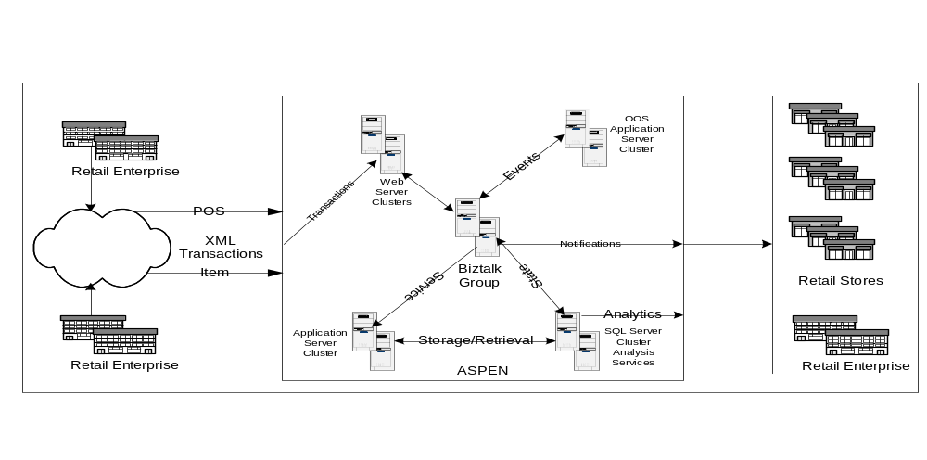

Anatomy
ASPEN is a hosted web service environment. Its primary function is to deliver the consumer demand signal (OOS notification) for the retail enterprise customer. It consists of a multi-server web cluster as shown in the diagram.

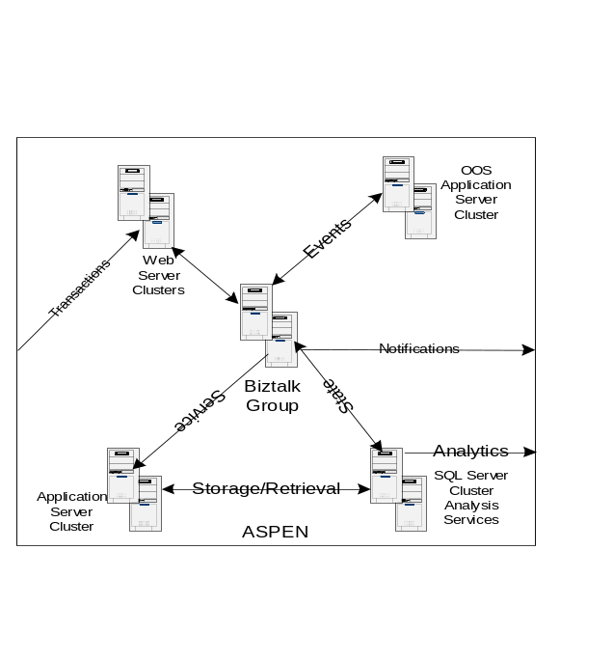
Windows 2000 Advanced Server Web Cluster
Provide all HTTP and HTTPS connectivity. This cluster serves as the interface to the BizTalk Server Group through ASP driven HTTPS Receive Functions. The customer has the ability to VPN into our Web Cluster and use FTP. This cluster will also contain the Web Interface for managing access to Demand Signal Notification Services.

BizTalk Server Group Cluster
Provides all message and data routing for ASPEN. Open Channels and Message ports are used to derive transport and destination information from data contained in the incoming XML data from the Enterprise Retailer. The transport and destination information are derived from a SQL Server 2000 database.

Rational for using Open Message Ports and Channels:
“When you create a channel for an open messaging port, and the destination information is provided in the document, the inbound document definition for that channel must reference a specification that is properly configured.

You can use an open messaging port to send one or more standardized documents to many different current or future trading partner organizations without creating a messaging port for each destination. All documents share the same envelope, security, and transport properties that are established in the messaging port.”

Application Server Cluster
The Application Servers contain the Business objects required for the Demand Signal Notification System. As well as COM+ objects for the Web Interface.

SQL Server / Analysis Services Cluster
The SQL Server Cluster will contain the BizTalk databases for managing state. It could also act as a repository for POS and Item promotion data into a data warehouse based on the ARTS data model fed by the IXRetail XML data model definitions. Retail specific Business Intelligence Cubes would then be generated sold as a Web Service to the Enterprise Retail Customer.

OOS Application Server Cluster
This cluster of servers contains the Data Ventures Demand Signal Algorithm for determining what items are out of stock for a store given POS and Item History. Point of Sale data will be sent to this algorithm to be processed to determine what is out of stock at that store. Then a message will be routed back to BizTalk to be sent back to SMTP pagers.

Functional Overview
The Consumer Demand Signal Service detects out of stock conditions in a live store environment and notifies store personnel of these issues. The service is driven by near real-time data feeds of the store's transaction data. This movement and pricing data is supplemented by item and promotional data feeds. A subscription service manages delivery of the events and alarms to the users. There are two functional domains of this offering:

Retail Integration & Operations Services (RIO)
RIO integrates the retail enterprise and its data into Consumer Demand Signal Service. RIO is broken into two subsystems: RIO Inputs and RIO Outputs.
- RIO Inputs focuses on integrating Point of Sale, item, and promotion batched data into the hosted ASPEN service via secured XML data transfers over HTTPS or VPN connections.
- RIO Outputs focuses on message routing to the endpoint devices and systems supported by Consumer Demand Signal Service. RIO Outputs currently supports Motorola, Blackberry, and other SMTP pager devices only. Future versions of this offering will support Symbol’s Retail Commercial Infrastructure Systems. Both Motorola and Blackberry devices were used in the offering pilots at Meijer and Food Lion.

Application Service Provided Enterprise Notification System (ASPEN)
ASPEN is a hosted application service that is responsible for accepting RIO Inputs, sending them to the out of stock Notification algorithm for processing, and accepting and routing outbound messages as a result of that processing to RIO Output Devices, Web Services, and Retail Commercial Systems. ASPEN is an application service; it is constructed to support multiple retail enterprises with thousands of retail grocery stores and data. A web service, ASPEN Slopes, is designed to maintain retail, store, user, device, and subscription data as well as provide the required accounting and operational facilities for managing the business of the Consumer Demand Signal Service.

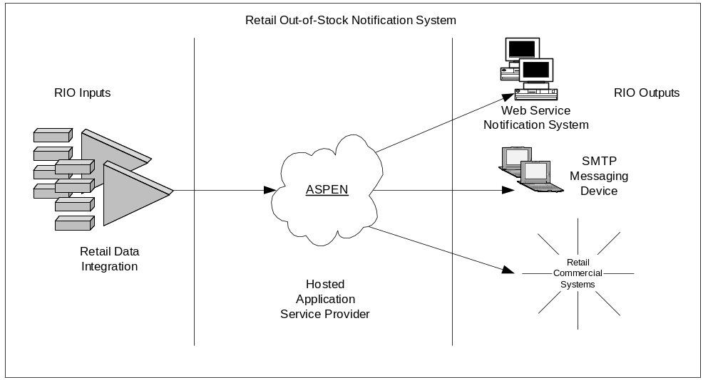

Consumer Demand Detection Algorithm
The Consumer Demand Signal Service relies on the Data Ventures' XPLOSS algorithms to learn normal item velocities and detect statistical variances from these such as "moving too fast", "moving to slow", "new item", "dropped item", and out of stock (OOS). XPLOSS learns best from minute-by-minute transaction data containing the details of what items were observed and at what price for every transaction. In the supermarket context, a transaction is a "shopping basket checkout", and observations are UPCs or item codes scanned by the checker. For every transaction, the data includes at least a time stamp, a series of items identified by UPCs or item codes, the item quantities, and the net price of each item or the regular price plus applicable discounts.

Training of the XPLOSS algorithm yields a model of item velocity for each monitored item at each monitored store under various merchandising conditions. The XPLOSS algorithm does this by transforming historical item movement data (across 1 or more stores) into a series of "event observations" whose arrival times behave in a random, statistically independent way called a Poisson process. The details of this transformation are proprietary and confidential to Data Ventures and P&G. The XPLOSS model accounts for current price, time of day and day of week, store name and current store traffic, current promotions, in-store competition, and seasonality. When the model is first trained, it is used to detect OOS, new item, and dropped item events. These events are then used to "adjust" the historical data, which the model retrains to improve its accuracy. The model is automatically rebuilt every 15 minutes to 24 hours, depending on the specific installation.

New transaction data is fed to the XPLOSS model to answer the question "What is the probability of the newly observed transaction data given the normal velocity model?" (Note that "normal velocity" takes into account current conditions such as price, promotion, traffic, etc.) If there is a small probability of the data being what it is or more extreme (e.g., slower/faster sales), then an anomaly event is generated. The kind of event (new item, dropped item, OOS, fast, slow) depends on the transaction data and model rules. These rules are adapted for specific installations. Events are immediately stored into the events cache so they can be accessed by the events server. Certain velocity model details, such as expected item velocities and historical item sales are put into the cache as well.

The item movement, velocity, and event cache contents can be accessed at any time via a client connection to the cache server. Either an XML or HTML client currently makes these connections. The server supports detailed reporting (e.g., individual events or item velocities, most recent item sale) and summarization (e.g., service level over the past month, current OOS event losses exceed some threshold, observed item velocity over the past day). The cache is normally updated every 15 minutes. The DV/P&G Item Velocity Monitor consists of:
- A data feed (for trickled TLOGs and daily Item Tables)
- Data handlers (RCO, POS_DATASOURCE, XPDATAREADER, XPIVMDBWRITE)
- A high-speed, compressed transaction database (XPDB, XPSORT)
- A velocity monitoring and out of stock (OOS) detection algorithm (XPLOSS)
- An item movement and velocity/OOS events cache and server (IVMSERVER)
- A web server (http daemon)
- An HTML events formatter (CGI bin IVMCLIENT)
- An XML events formatter (notification client IVMALERT)
- A processing scheduler (cron)
- A batch process script (IVMDRIVER)
- A messaging server (BizTalk)

Process Flows
The diagram below describes the Fireball Pilot Process. The process begins with a data file being sent from Data Ventures (XML), which contains out of stock (OOS) Alarm, or Data Flow Alarm. A file from Data Ventures will only contain one type of data. Meaning a file will never arrive at the BizTalk Server containing both alarms and OOS data.

The destination of the message is contained in the database. The pre-processors derive those addresses based on information contained in the XML message.

Messages are finally routed to a SMTP Address, which could be a pager or an email client.

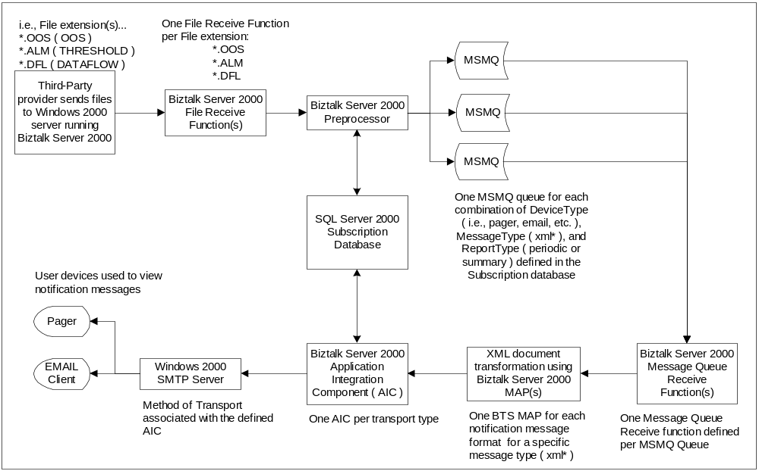

RIO Inputs
Each retailer will have its own methods and systems for collecting and storing Point of Sale (POS) transaction data and their item and promotional data. Some retailers will have a centralized spoke hub model; some will have a decentralized model. The main goal of RIO inputs is to understand the retailer's data and to translate this data into an XML format for transfer into ASPEN. Analysis and understanding the structure and definition of data is critical to the success of RIO Inputs.

Standardized XML schema and instances of the data required by ASPEN have been defined. If additional data integration is required, the BizTalk Sales Transaction Schema described by the ActiveStore initiative is useful.

